**Bahria University, Lahore Campus**

Department of Computer Sciences

Lab Journal 02

**(spring 2024)**

|  |  |  |
| --- | --- | --- |
| Course: | **Operating System Lab** | Date: 2/29/2024 |
| Course Code: | CSL - 320 | Max Marks: 20 |
| Faculty’s Name: | ABDULLAH |  |

Name: Muhammad Hammad Enroll No: 03-134221-024

Objective(s) :

To study and execute the commands in Linux.

## Lab Tasks :

# Lab 02: LINUX Commands

**Objective(s):**

* To study and execute the commands in Linux.

**Tool(s) used:**

Ubuntu

**General Purpose utility LINUX Commands**

**Task 01** Execute the Date Commands and write the output.

This command is used to display the current data and time.

**Syntax:** $date

## Output:

**Options:**

|  |
| --- |
| a = Abbrevated weekday. |
| A = Full weekday. |
| b = Abbrevated month. |
| B = Full month. |
| c = Current day and time. |
| C = Display the century as a decimal number. |
| d = Day of the month. |
| D = Day in „mm/dd/yy‟ format |
| h = Abbrevated month day. |
| H = Display the hour. |
| m = Month of the year. |
| M = Minute. |
| P = Display AM or PM |
| S = Seconds |
| T = HH:MM:SS format |
| y = Display the year in 2 digit. |
| Y = Display the full year. |
| Z = Time zone. |

To change the format:

**Syntax:** $date +%H-%M-%S

## Output:

## 

Calendar Command

This command is used to display the calendar of the year or the particular month of calendar year.

**Syntax**

$cal year

$cal month year

Here the first syntax gives the entire calendar for given year & the second Syntax gives the calendar of reserved month of that year.

## Output:

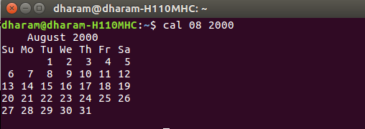

**Task 02** Execute the below mentioned LINUX Commands and generate output.

Echo Command

This command is used to print the arguments on the screen.

**Syntax:** $echo text

## Output:

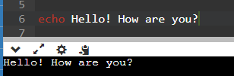

Banner Command

It is used to display the arguments in „#‟ symbol.

**Syntax:** $banner <arguments>

## Output:

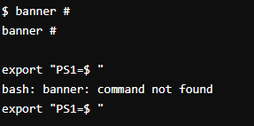

‘ who’ Command

It is used to display who are the users connected to our computer currently.

**Syntax:** $who – option’s

**Options**

* H–Display the output with headers.
* b–Display the last booting date or time or when the system was lastely rebooted.

## Output:

## 

‘whoami’ Command

Display the details of the current working directory.

**Syntax:** $whoami

## Output:



‘Binary’ Calculator Command

It will change the „$‟ mode and in the new mode, arithmetic operations such as +,-,*,/,%,n,sqrt( ),length( ),=, etc can be performed. This command is used to go to the binary calculus mode.

**Syntax:** $bc operations ^d

* 1 base – input base
* 0 base – output base are used for base conversions.
* Base: Decimal = 1 Binary = 2 Octal = 8 Hexa = 16

## Output:

‘CLEAR’ Command

It is used to clear the screen.

**Syntax:** $clear

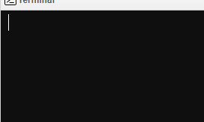

**Task 03** Execute the below File Commands and write the output.

Create a File

To create a new file in the current directory we use CAT command.

**Syntax:**

$cat > filename.

The > symbol is re-directory we use cat command.

## Output:

## 

Display A File

To display the content of file mentioned we use CAT command without “>‟ operator.

**Syntax:**

$cat <filename.

Options –s = to neglect the warning /error message.

## Output:

Copying Contents

To copy the content of one file with another. If file does not exist, a new file is created and if the file exists with some data then it is appended.

**Syntax:**

$ cat source filename >> destination filename it is to avoid overwriting.

**Options:** -n content of file with numbers included with blank lines.

**Syntax:** $cat –n filename

## Output:

Copying Contents From One File To Another

To copy the contents from source to destination file. so that both contents are same.

**Syntax**

$cp source filename destination filename

## Output:

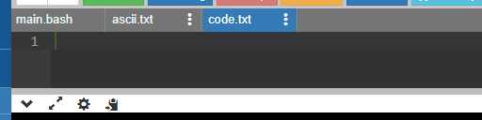

After copying data and running code:

MOVE Command

To completely move the contents from source file to destination file and to remove the source file.

**Syntax:** $ mv source filename destination filename

## Output:

After moving:

REMOVE Command

To permanently remove the file we use this command.

**Syntax:** $rm filename

## Output:

WORD Command

To list the content count of no of lines, words, characters.

**Syntax:** $wc filename

**Options:**

* -c – to display no of characters. -l – to display only the lines.
* -w – to display the no of words.

## Output:

**Task 04** Execute FILTERS AND PIPES commands and write the output

HEAD

It is used to display the top ten lines of file.

**Syntax:** $head filename

## Output:

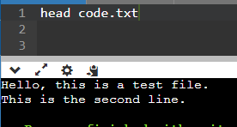

TAIL

This command is used to display the last ten lines of file.

**Syntax:** $tail filename

## Output:

SORT

This command is used to sort the data’s in some order.

**Syntax:** $sort filename

## Output:

PIPE

It is a mechanism by which the output of one command can be channeled into the input of another command.

**Syntax:** echo 1+1**|**bc

## Output:

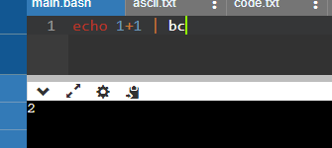

TR

The tr filter is used to translate one set of characters from the standard inputs to another.

**Syntax:** $tr “[a-z]” “[A-Z]”

## Output:

## 

**Lab Grading Sheet :**

|  |  |  |  |
| --- | --- | --- | --- |
| **Task** | **Max Marks** | **Obtained Marks** | **Comments(*if any*)** |
| 1. | 5 |  |  |
| 2. | 5 |  |  |
| 3. | 5 |  |  |
| 4. | 5 |  |  |
| **Total** | **20** |  | **Signature** |

**Note : Attempt all tasks and get them checked by your Lab. Instructor**